**CECS 006 – SYSTEM ADMINISTRATOR**  
**DEGREE CONTINUOUS ASSESSMENT TEST – I & II (2025)**

### PART A (7 x 2 = 14)

1. **Define Automate Everything:**

Automating everything means creating scripts, tools, or processes that eliminate the need for manual intervention in repetitive tasks.

For example,

* automatic backups,
* user account creation, and
* log analysis in system administration.

1. **Present unique statement about Procedures:**

Procedures are pre-written SQL statements grouped into a single unit for reusability and performance optimization.

They help in

* encapsulate logic,
* reduce redundancy, and
* improve data integrity.

1. **Mention the text editors in Red Hat Enterprise Linux:**

Text editors are essential tools for creating, modifying, and managing text-based files. They are fundamental for system administrators, developers, and anyone working with configuration files, scripts, or cod

Common editors in RHEL include:

* + vi
  + vim
  + nano
  + gedit

1. **Express the concept of CentOS:**



CentOS (Community ENTerprise Operating System) is a free, open-source Linux distribution derived from Red Hat Enterprise Linux (RHEL).

It offers enterprise-level performance and stability.

1. **List the Key file System in RHEL:**

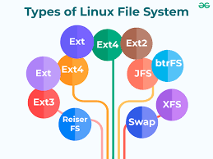

* + ext3
  + ext4
  + XFS (default since RHEL 7)
  + Btrfs (experimental)

1. **Delineate Linux:**

Linux is an open-source, Unix-like operating system kernel used in servers, desktops, and embedded systems.

It supports

* multitasking,
* multi-user capabilities, and
* Strong security.

1. **Depict the tmp:**

The /tmp directory stores temporary files created by system processes or users. Files in /tmp are often deleted at boot or after a time interval.

### PART B (3 x 4 = 12)

* 1. **Explicate the Communicate As Much As Possible in system administrator:**

Communication is key for a system administrator. Whether updating users on maintenance, collaborating with developers, or documenting changes, clear and frequent communication prevents misunderstandings, improves response times, and ensures accountability.

OR

* 1. **Prepare the example of bank teller:**

A bank teller interacts with a database to retrieve and update customer information. The teller’s system runs queries like:

* SELECT balance FROM accounts WHERE account_number = '12345';
* This is an example of front-end accessing the database in a controlled, secure environment.
  1. **Explain about the RAID:**

RAID (Redundant Array of Independent Disks) is a method of storing data across multiple hard drives to improve performance and provide redundancy.

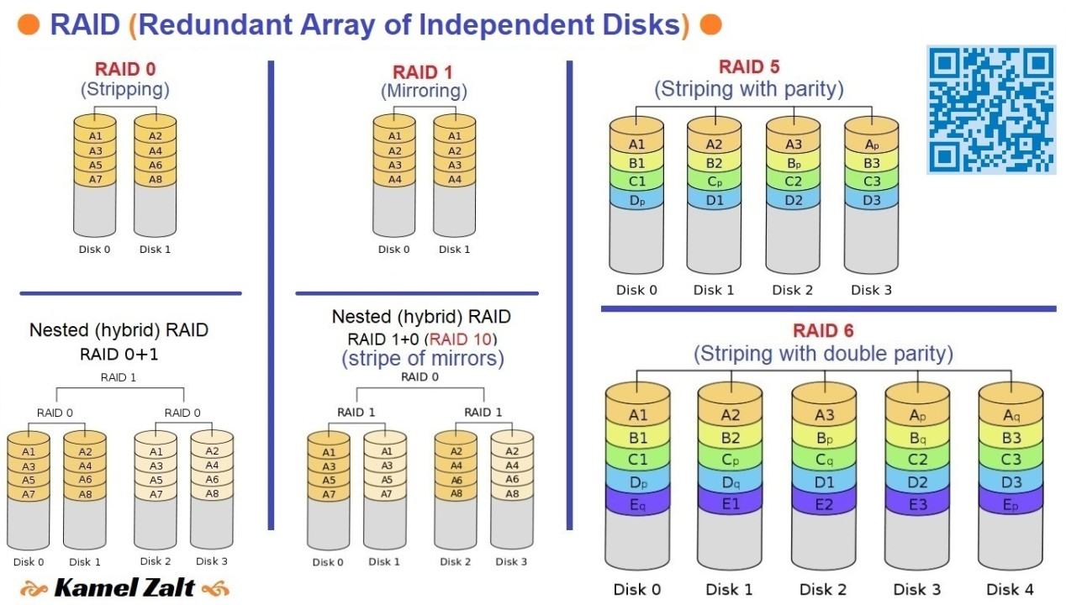

Types include:

* + RAID 0 (striping)
  + RAID 1 (mirroring)
  + RAID 5 (striping with parity)
  + RAID 10 (combination of RAID 1 + 0)

OR

* 1. **Expound the update the system in RHEL:**

RHEL stands for Red Hat Enterprise Linux. It's a commercial Linux distribution developed by Red Hat, targeted towards the enterprise market.

Updating RHEL is done using yum or dnf commands:

* + sudo yum update
* This fetches new packages, fixes vulnerabilities, and ensures system stability.
  1. **Illustrate the CD command:**

The cd (change directory) command is used to move between directories:

cd /home/user/Documents  
cd .. # move one level up  
cd ~ # go to home directory

OR

* 1. **Describe the options of ls command:** The ls command lists directory contents. Useful options:
* -l: long listing format
* -a: include hidden files
* -h: human-readable sizes
* -R: recursive listing

Example:

ls -lah

### PART C (2 x 12 = 24)

* 1. **Explain the concept of Document Everything in system administrator:**



* Documentation is the backbone of good administration. Recording processes, configuration changes, network settings, and issue resolutions ensures continuity, reduces errors, and helps onboarding new admins. Use wikis, markdown files, or ticketing tools to maintain traceable logs.

**Six important reasons to document everything** as a System Administrator:

* **Troubleshooting Made Easy**
  + Clear documentation helps quickly trace and fix issues without guesswork.
* **Onboarding New Admins**
  + New team members can understand the system setup faster with written guides.
* **Disaster Recovery**
  + In case of system failure, documented procedures ensure quick and accurate recovery.
* **Consistency in Operations**
  + Ensures tasks like backups, updates, and security checks are done the same way every time.
* **Security and Compliance**
  + Helps meet audit requirements and tracks changes for accountability.
* **Saves Time Long-Term**
  + Reduces repetitive explanations and rework by having answers written once.

OR

* 1. **Discuss the concept of Red Hat Enterprise Linux:**
* RHEL is a commercial Linux distro designed for enterprises.
* It offers
  + - certified security,
    - long-term support,
    - patch management, and
    - access to Red Hat’s customer portal.
* It’s widely used in cloud computing, DevOps, and server environments.
  1. **Analysis the Role of a System Administrator in a Linux environment:** A Linux System Administrator is responsible for:
  + Installing and maintaining servers
  + User management and permissions
  + Managing disk space and backups
  + Securing the system (firewalls, SELinux)
  + Monitoring system health (logs, load, uptime)
  + Automating tasks with shell scripts or cron jobs

OR

* 1. **Enlighten the basic features of Linux:**
* Open-source and free
* Multi-user and multitasking
* Secure (permissions, firewalls, encryption)
* Customizable (modular kernel, CLI tools)
* Stability and performance for enterprise use
* Powerful command-line utilities

## 

### PART A (7 x 2 = 14)

* 1. **Provide the syntax for using the** rm command

The rm command is used to remove files or directories. The basic syntax is:

**rm [options] file_name**

Example:

**rm test.txt**

To remove a directory recursively:

**rm -r folder_name**

**2. Identify any 4 options in** ls command

Answer:

* ls -l : Lists files in long format (permissions, ownership, size, etc.)
* ls -a : Lists all files including hidden files (starting with .)
* ls -h : Human-readable file sizes
* ls -R : Recursively lists subdirectories

**3. Present unique statement about File Structures,**

**Answer:**  
File structures in an operating system define how data is logically stored, accessed, and organized, forming the core abstraction layer that allows programs and users to interact with persistent storage seamlessly.

**4. Identify the purpose of the** seekdir() function in C

**Answer**:

seekdir()repositions the location of a directory stream to a position previously obtained usingtelldir(). It is used when reading directories with readdir()` to resume reading from a specific point.

**5. Provide the syntax of** `w+(write + read)

**Answer**:

In C, w+is used in fopen()` to open a file for both writing and reading:

Example of use:

FILE *fp = fopen("file.txt", "w+");

**6. Infer the Inter Process Communication**

**Answer:**  
Inter Process Communication (IPC) refers to mechanisms that allow processes to communicate and synchronize their actions. Examples include pipes, message queues, shared memory, and semaphores.

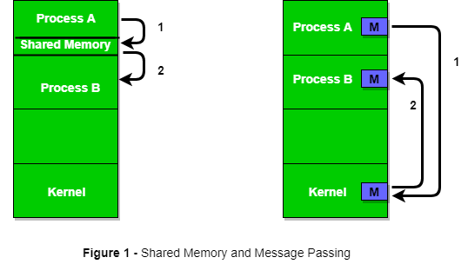

**7. Define Named Pipes**

**Answer:**

Named Pipes (FIFOs) are a type of IPC that allow unrelated processes to communicate. Unlike anonymous pipes, they have a name and exist as a special file in the filesystem.

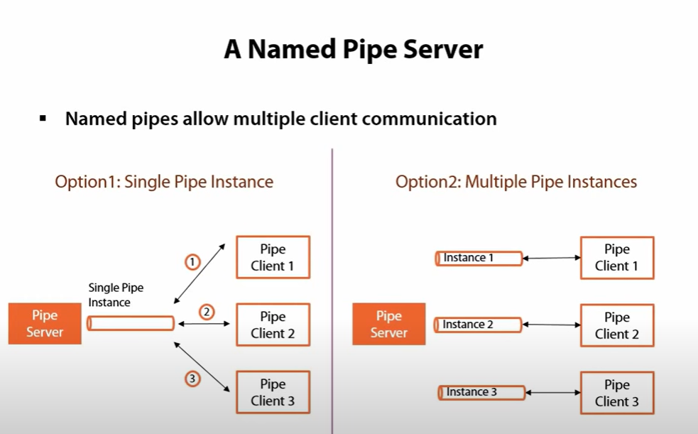

Pipes are created using:

mkfifo mypipe

### PART B (3 x 4 = 12)

**8.(a) Enlighten the purpose of the** cat command in Linux

Answer:

The cat` (concatenate) command is used to read, display, and combine files. It outputs file contents to the terminal, which is useful for viewing short text files, combining multiple files, or redirecting output into a new file.

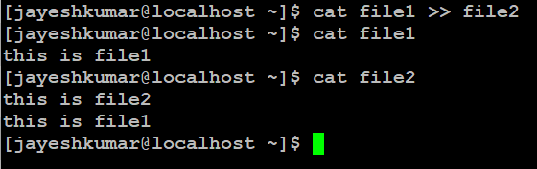

Example:

cat file1.txt file2.txt > combined.txt

**OR**

**8.(b) Provide an example to demonstrate the use of**  ln command

Answer:

The ln` command creates links between files. The links can be of two links:

* Hard link:

ln original.txt hardlink.txt

* Symbolic link (shortcut):

ln -s original.txt symlink.txt

**9.(a) Define a file system and mention the command used to check the block size in a Unix file system**

**Answer:**

A file system manages how data is stored and retrieved. It organizes data into files and directories and keeps metadata. To check block size:

stat -f filename

Or use:

blockdev --getbsz /dev/sdX

**OR**

**9.(b) List the different types of file I/O functions available after opening a file in C**

**Answer:**

• **fopen() / fclose()** – Open and close a file.

• **fread() / fwrite()** – Read/write binary data.

• **fprintf() / fscanf()** – Write/read formatted text.

• **fgets() / fputs()** – Read/write text lines.

• **fseek() / ftell()** – Move/get file pointer position.

• **fflush()** – Force write of buffered output.

**10.(a) Explain about the Remote Procedure Calls (RPC)**

**Answer:**

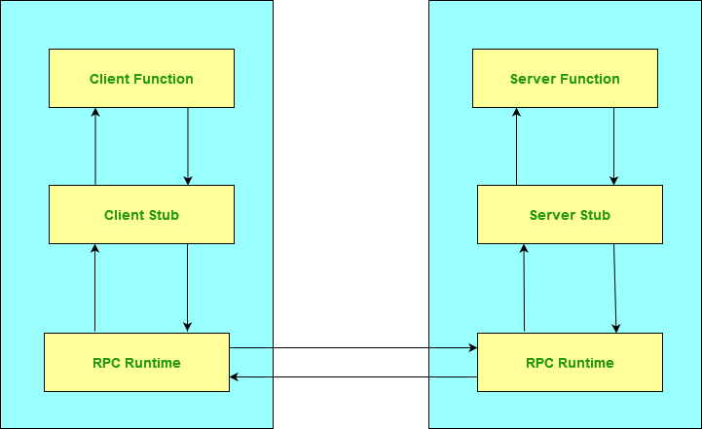

RPC enables a program to invoke a procedure on another address space (commonly on another computer on a network), abstracting the complexity of communication. It allows modular and distributed applications.

**OR**

**10.(b) Write a program for Reading Output from a Command**  
**Answer:**  
Using popen():

#include <stdio.h>  
int main() {  
 char buffer[128];  
 FILE *fp = popen("ls", "r");  
 while (fgets(buffer, sizeof(buffer), fp)) {  
 printf("%s", buffer);  
 }  
 pclose(fp);  
 return 0;  
}

### PART C (2 x 12 = 24)

**11.(a) Explain the purpose of the**

* rm command : Deletes files or directories. Irreversible.
* cd command : Changes the current directory.

**Options and Syntax:**

**rm command options:**

1. rm -r directory_name – Remove a directory and its contents recursively
2. rm -f file.txt – Forcefully delete a file without confirmation
3. rm -i file.txt – Prompt for confirmation before deleting

**cd command options:**

1. cd .. – Move to the parent directory
2. cd ~ – Move to the home directory
3. cd - – Switch to the previous directory

Example of use:

rm file.txt  
cd /home/user

**OR**

**11.(b) Describe the** cp command in Linux and how it is used to copy files and directories

Answer:

cp is used to copy files and directories.

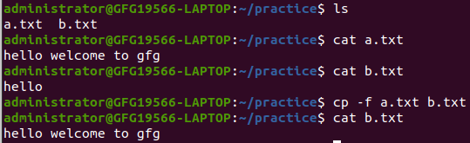

Common options:

* cp file1.txt file2.txt → Copy file1 to file2
* cp -r dir1 dir2 → Copy entire directory recursively
* cp -u → Copy only when source is newer
* cp -i → Prompt before overwriting

**12.(a) Summarize the concepts of files, streams, and file types in C programming**

**Answer:**

* **Files**: acts as a box/component that stores data.

In C, we represent it with a pointer FILE *. You open it with fopen(), use it, then close it with fclose().

Example:

FILE *fp = fopen("data.txt", "r");

* **Streams**: A stream is a smart channel that moves data in or out (input/output).

There are standard streams: stdin (keyboard), stdout (screen), and stderr (errors). C uses these with functions like printf() or scanf().

* **File Types**:
  + *Text Files*: Human-readable (like .txt) with characters you can see.
  + *Binary Files*: Raw byte data (like .exe or .jpg) that only programs can interpret. Use fread()/fwrite() to handle them.

In short, think of:

* **Files** as where data lives,
* **Streams** as how data travels,
* **File types** as the format of data inside (visible or machine-only).

Summary:

* **Files**: Represented as FILE*, opened via fopen().
* **Streams**: Abstractions for file I/O (stdin, stdout, stderr).
* **File types**: Text files (readable) vs. Binary files (raw byte data). Streams simplify I/O with consistent functions for both file and device input/output.

**OR**

**12.(b) Discuss the concept of Semaphores with illustration**

**Answer:**

Semaphores are synchronization tools used to control access to shared resources in concurrent systems.

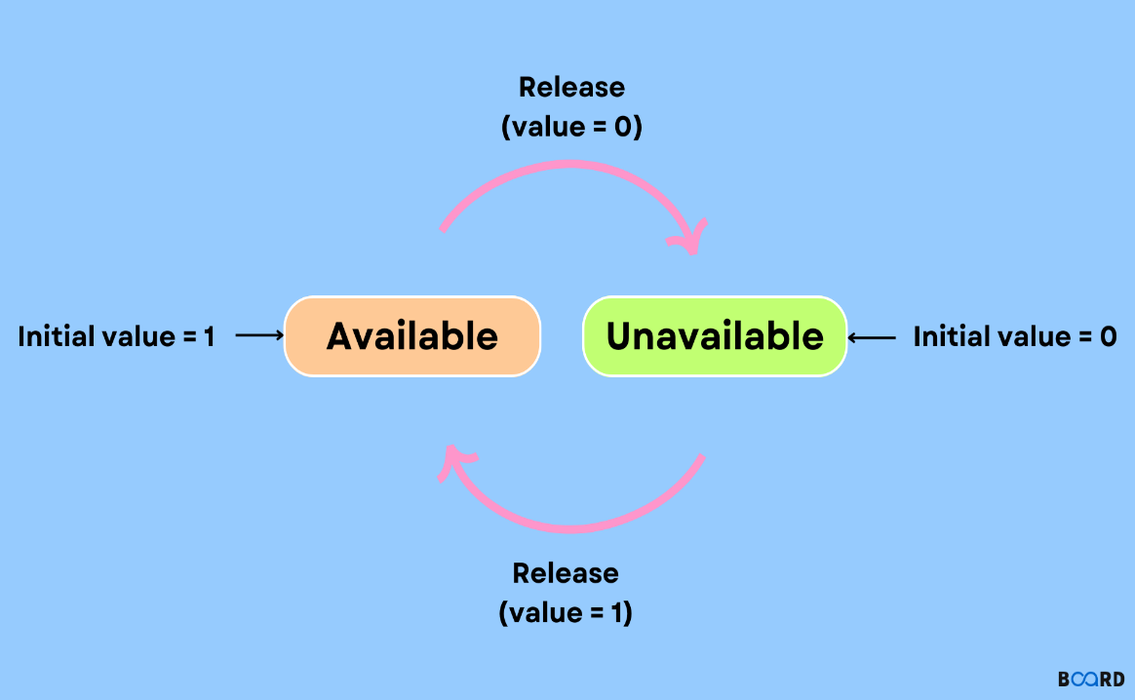

* **Binary Semaphore**: Acts like a lock (0 or 1)
* **Counting Semaphore**: Allows multiple instances

**Example (Pseudo-C):**

sem_t mutex;  
sem_init(&mutex, 0, 1);  
sem_wait(&mutex); // Enter critical section  
// Shared resource  
sem_post(&mutex); // Exit

They prevent race conditions and ensure mutual exclusion.

**END OF CORRECTION**